

# Idea 01- Skin Lesions

1. **Objective: What should we do?**

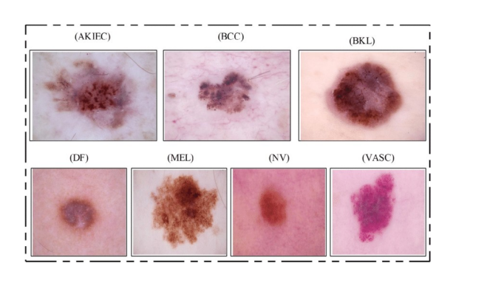

We aim to train a machine learning model with image detection and recognition algorithms to detect skin lesions. Our users should input several images of their suspicious skin lesions to the model and get basic medical advice such as the categories of it, the possible symptoms, whether benign or malignant, recommended preventive and therapeutic measures of the skin lesions.

Ref: <https://my.clevelandclinic.org/health/diseases/24296-skin-lesions>

* 1. **Why should we do that?**

The skin lesions can be divided into benign and malignant. Skin lesions that are benign are noncancerous and often harmless, but the malignant ones are skin cancer which harmed health badly. Skin cancer is the most common type of cancer in the U.S. Each 1 in 5 people will develop skin cancer in their lifetime, with an estimated 9,500 people diagnosed daily. However, most people lack related knowledge about skin lesions and may cause potential risk. With skin cancer, early detection generally leads to a better outcome, which showed great value for our applications both on the society and business.

1. **Data: Where do we get the data?**

Ref:<https://dataverse.harvard.edu/dataset.xhtml?persistentId=doi:10.7910/DVN/DBW86T>

<https://www.kaggle.com/datasets/kmader/skin-cancer-mnist-ham10000>

The HAM10000 dataset, a large collection of multi-source dermatoscopic images of common pigmented skin lesions.

The final dataset consists of 10015 dermatoscopic images which can serve as a training set for academic machine learning purposes. Cases include a representative collection of all important diagnostic categories in the realm of pigmented lesions.

1. **Experience: Who should we learn from?**

Ref: <http://skin.test.woza.work/>

<https://www.kaggle.com/code/vbookshelf/skin-lesion-analyzer-tensorflow-js-web-app>

<https://www.kaggle.com/code/xinruizhuang/skin-lesion-classification-acc-90-pytorch>

many different projects about skin lesions and HAM10000

1. **Model: What model should we train?**

* Typically Neural Network (MobileNet, Densenet , etc.)
* Neural network has a better performance on high-dimensional features.

1. **Evaluation： Are our results good enough?**

* Cross validation
* Confusion matrix
* F1-score
* ROC Curves
* Etc.

1. **Appearance：How does the product look like? (GUI)**

* Mobile App (sign up & login, support camera to take images, archives, documents export/import, re-check reminder)
* Website (uploading images, similar functions like APP)
* Additional medical advice and related knowledge
* Results link to doctors (e.g. API for doctolib.de/)

1. **Problem: What’s the pain point of the project?**

* Data unbalanced
* OOD Detection
* Monte Carlo Dropout Uncertainty
* Etc.



# Idea 02- Dog Breeds

1. **Objective: What should we do?**

In recent years, there has been a high incidence of injuries caused by domesticated powerful dogs in China's cities. Incidents of stray dogs injuring people in neighborhoods have also occurred from time to time.

We would like to create an app that can be applied to mobile, where a mobile phone can take a photo or upload a photo of a dog to give the breed of the dog and relevant information under that breed to facilitate staff screening.

* 1. **Why should we do that?**

This is because most of the staff involved in community management are not professional law enforcement officers, and most of them are in the form of community workers or even volunteers. Most of them have a low level of education and many of them are even elderly volunteers. It is difficult for them to identify multiple dog breeds. If there is a mobile software that can take photos to identify dog breeds, it will be more helpful in managing urban domesticated dogs and stray dogs. This can also be used as a form of evidence to be retained in the subsequent administrative process.

1. **Data: Where do we get the data?**

Ref: <http://vision.stanford.edu/aditya86/ImageNetDogs/>

The Stanford Dogs dataset contains images of 120 breeds of dogs from around the world. This dataset has been built using images and annotation from ImageNet for the task of fine-grained image categorization.

1. **Experience: Who should we learn from?**

Ref: <https://www.kaggle.com/code/thiennguyen15/predicting-dog-species-using-resnet50>

https://www.kaggle.com/code/akshitsharma1/generative-adversarial-networks-gan-in-one-shot

<https://link.springer.com/article/10.1007/s11633-020-1261-0>

1. **Model: What model should we train?**

* Typically Neural Network (Resnet, Generative Adversarial Networks , etc.)

Ref: <https://www.kaggle.com/code/thiennguyen15/predicting-dog-species-using-resnet50>

https://www.kaggle.com/code/akshitsharma1/generative-adversarial-networks-gan-in-one-shot

1. **Evaluation： Are our results good enough?**

* Cross validation
* Confusion matrix
* F1-score
* ROC Curves
* Etc.

1. **Appearance：How does the product look like? (GUI)**

* Mobile App (sign up & login, support camera to take images, archives, documents export/import)
* Website (uploading images, similar functions like APP)

1. **Problem: What’s the pain point of the project?**

* Etc.



# Idea 03 - Track-Football-Player

1. **Objective: What should we do?** 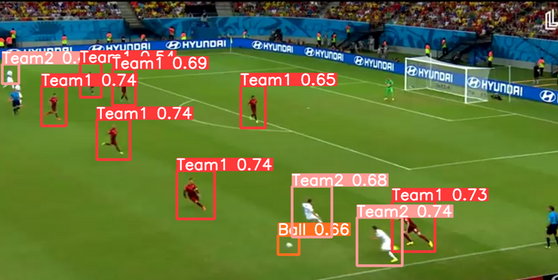

In this project, our ultimate goal is to develop a system that assists football-related video bloggers in automatically extracting player positions from a frame of a football match video. This system will segment players based on jersey colors into two teams and generate text boxes as required for subsequent manual identification of recognized players (including number, field position, name, age, etc.).

1. **Data: Where do we get the data?**

Ref: <http://suo.nz/2VNhKp>

(PS：<http://suo.nz/2GKRSL> /*To determine if an image is related to football.*/ )

Our preferred approach is to utilize pre-annotated datasets. Additionally, we can extract images from existing match videos by selecting key frames and then manually annotate them.

1. **Experience: Who should we learn from?**

Ref: https://github.com/IsaWdx/Track-Football-Player/blob/master

We've searched for relevant resources and previous experiences on GitHub and Kaggle, but currently, we haven't found very closely related projects. We may need to explore gradually and navigate this ourselves.

1. **Appearance：How does the GUI look like?**

* Website (Upload an image and receive the annotated image in return.
* Feature panels used for annotating tactics, such as arrows or circles.

**DeadLock**

**16.11.2023**